PROJECT PLANNING PHASE

SPRINT DELIVERY PLAN

|  |  |
| --- | --- |
| Date | 28 oct 2022 |
| Team ID | PNT2022TMID49040 |
| Project Name | AI-Powered Nutrition Analyzer for Fitness Enthusiasts |

Sprint Delivery Plan :

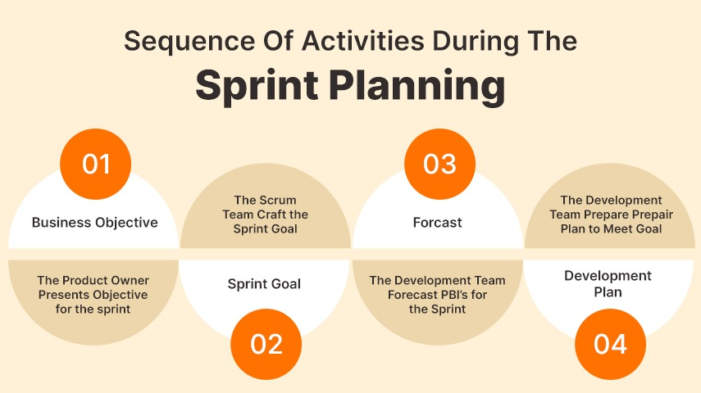 Every project manager should consider the delivery strategy of the project deliverables as a strategic component. Every project's objective is to deliver a product that fulfils a certain need. The word "purpose" can be used to refer to a wide range of objectives, including those for a chair, a building, a translation, etc. Delivery planning is one of the activities used in Project Spirit to finish the project and display the projected timeline. This delivery plan aids in comprehending the team members' workflow and project procedure. Each individual module is given to a team member so they can showcase their efforts and contributions to the project's development.